Computer Shop System

Use-Case Specification: Delete Order

Version 1.0

Revision History

|  |  |  |  |
| --- | --- | --- | --- |
| **Date** | **Version** | **Description** | **Author** |
| 5/12/2019 | 1.0 | None | Pham Thi Hong Trang |
|  |  |  |  |
|  |  |  |  |
|  |  |  |  |

Table of Contents

1. Use-Case Name 3

1.1 Brief Description 3

2. Flow of Events 3

2.1 Basic Flow 3

2.2 Alternative Flows 3

2.2.1 < First Alternative Flow > 3

2.2.2 < Second Alternative Flow > 3

3. Special Requirements 3

3.1 < First Special Requirement > 3

4. Preconditions 3

4.1 < Precondition One > 3

5. Postconditions 3

5.1 < Postcondition One > 3

6. Extension Points 3

6.1 <Name of Extension Point> 3

Use-Case Specification: Delete Order

# Use-Case Name

## Brief Description

This use case defines the steps of removing an existing order from the system. Administrator can easily remove an order from the system.

# Flow of Events

## Basic Flow

When staff have some contacts to confirm about the order’s customer. If customer want to cancel this order. Administrator will delete this order in manage order system.

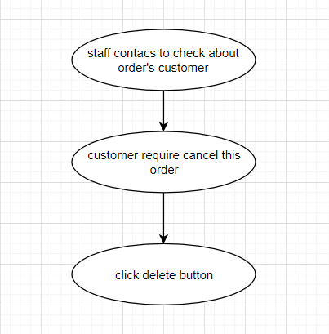

# Special Requirements

## < None Special Requirement >

# Preconditions

Computer shop have request cancel order from customer.

# Post conditions

## No post conditions.

# Extension Points

No extension points.